Website Design Questionnaire

Want to create beautiful, standardized questionnaires that help your customers provide answers faster?
Try ManyRequests' intake forms, free for the first 14 days.

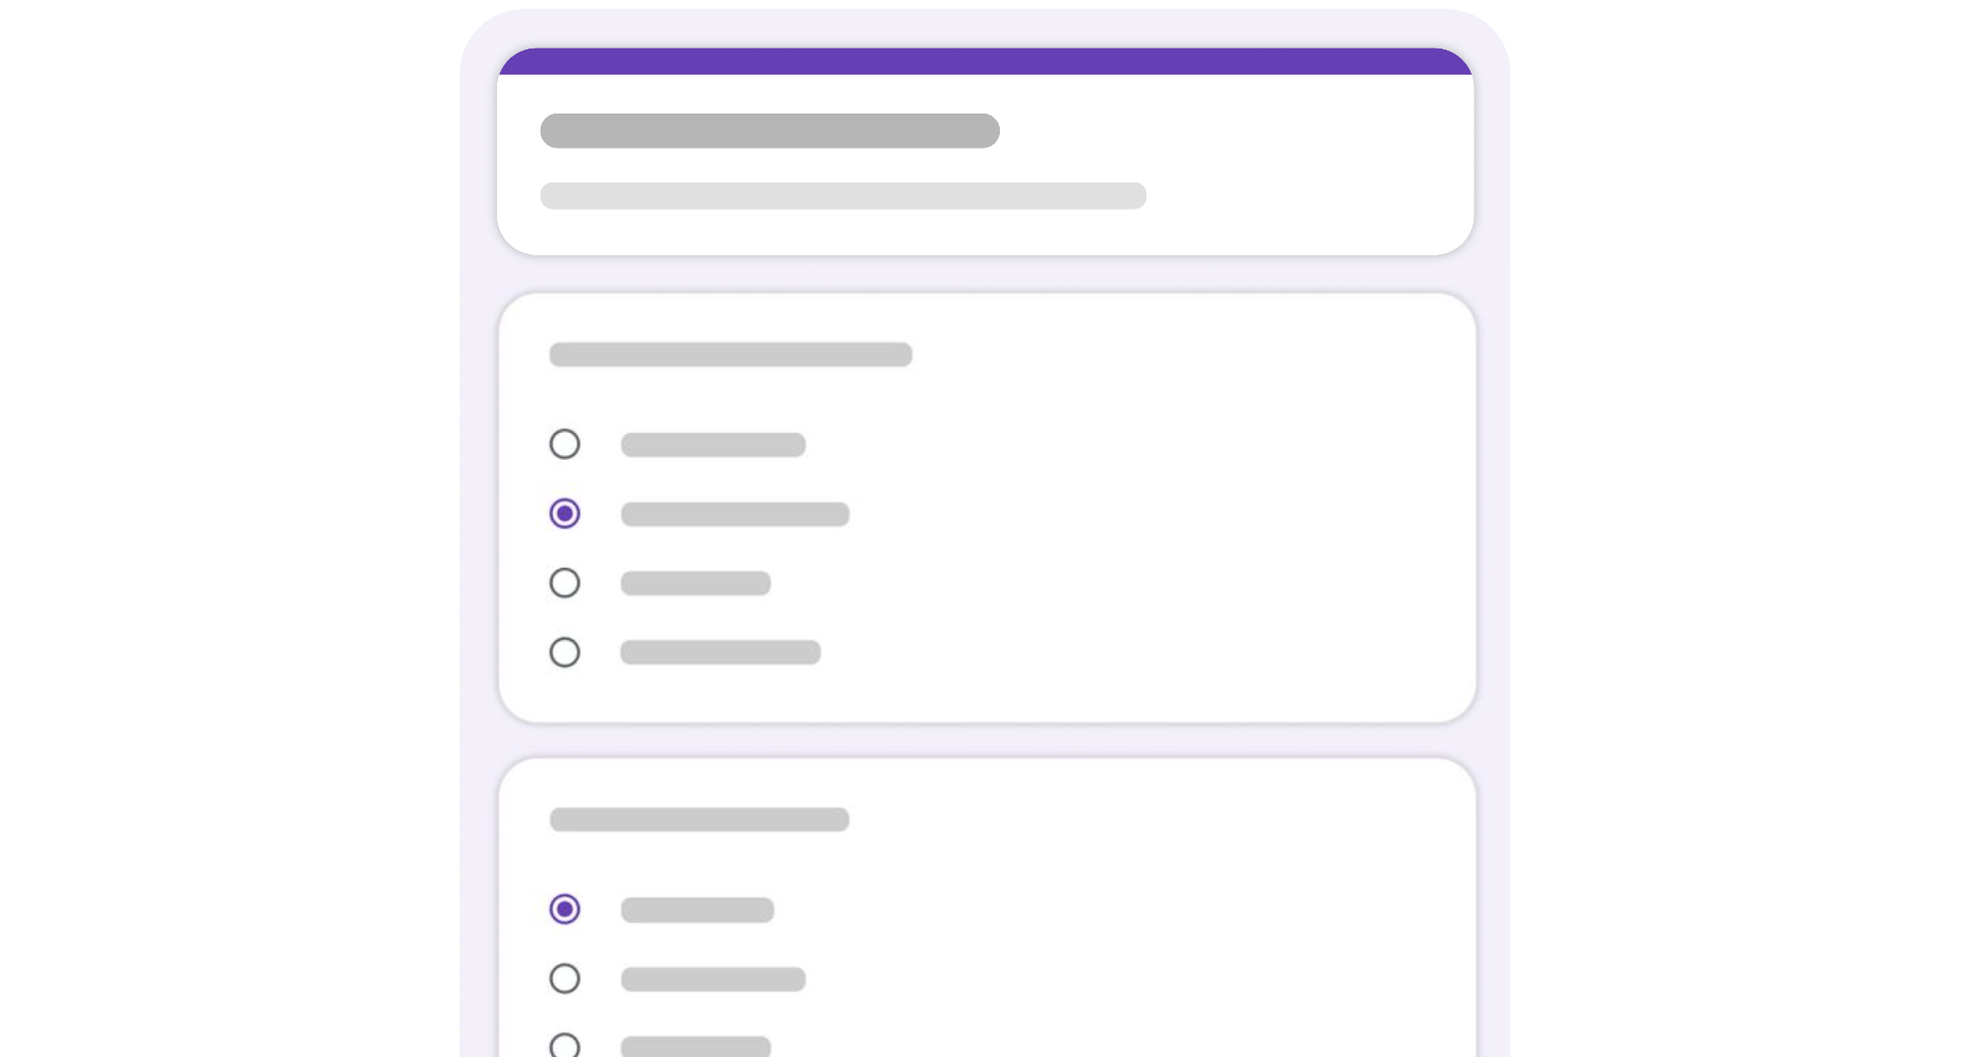

QUESTIONNAIRE TEMPLATE

Business Questions
These questions will help you gauge a customer's business model, making it easier to choose which design is best suited to their objectives. Ask for links if possible as they will remain available to you for reference in the future.

Please enter the link of your current website (if any):
Answer here

Provide a detailed description of what your company does, for whom, the typical sales process, and what the website should achieve (e.g. generate leads, sign people up to your software, etc.)
Answer here

What services do you want to highlight for the new website? List as many as relevant.
Answer here

Please provide a link to your buyer persona document or describe one of your typical buyers in a detailed manner:
Answer here

Please provide 1 or 2 links of a customer's website, or that of a company that's similar to one of your customers:
Answer here

Please provide 1 or 2 links of a competitor's website:
Answer here

Project Questions
These questions will help you scope the requirements of the website project and provide the customer with a quote. It's important to cover: How many pages they need, what type of pages, if it's a new website or a redesign, and what features they need (SEO, animations, etc.).

Do you need to create a new website or re-design one?
Answer here

What pages do you need on the new website? (About, Pricing, Features, etc.)
Answer here

When would you like to launch the new website?
Answer here

Do you already know what platform / CMS you want to use for this website?
Answer here

Do you already know which keywords you'd like to target for your SEO (Search Engine Optimization) efforts?
Answer here

Do you have a ballpark idea of the budget for this website?
Answer here

Post-Sale Questions
These questions will help you provide the customer with a website that is as close to their expectations as possible from the start, reducing the need for revisions and increasing the likelihood they'll be satisfied with your work.

Please provide 3 to 4 URLs of websites that inspire you:
Answer here

Why do they inspire you? What do you like about them?
Answer here

Describe your ideal website in a detailed manner. Include information like key messages you would like to include, your product positioning, and visual features you'd like to see (dropdowns, animations, large sections, etc.)
Answer here

Do you have any imagery or text to support the design process? If so, please provide links to the source files:
Answer here

Please provide a link to your brand guidelines (if any):
Answer here

Add any additional information required for us to deliver a great website:
Answer here

